## Interfacing with Sensors

**Aim**:

Introduction to sensors using Arduino and design and implement PIR sensor to detect movement up to 30’ away at 180 degrees (useful in motion-activated projects such as security system or automatic lighting).

**Code**:

int pirsensor = 0; //variable to store the sensor status (value)

void setup ()

{

pinMode(2, INPUT); //initialize sensor as an input

pinMode(11, OUTPUT); //initialize LED as an output

Serial.begin(9600); //initialize serial

}

void loop()

{

pirsensor = digitalRead(2); //read sensor value

if (pirsensor == 1) //checks if the sensor is HIGH

{

digitalWrite(11, HIGH); //turn LED on

Serial.println("Motion detected, presence of humans or animals");

}

else

{

digitalWrite(11, LOW); //turn LED off

Serial.println("Motion is not detected");

}

}

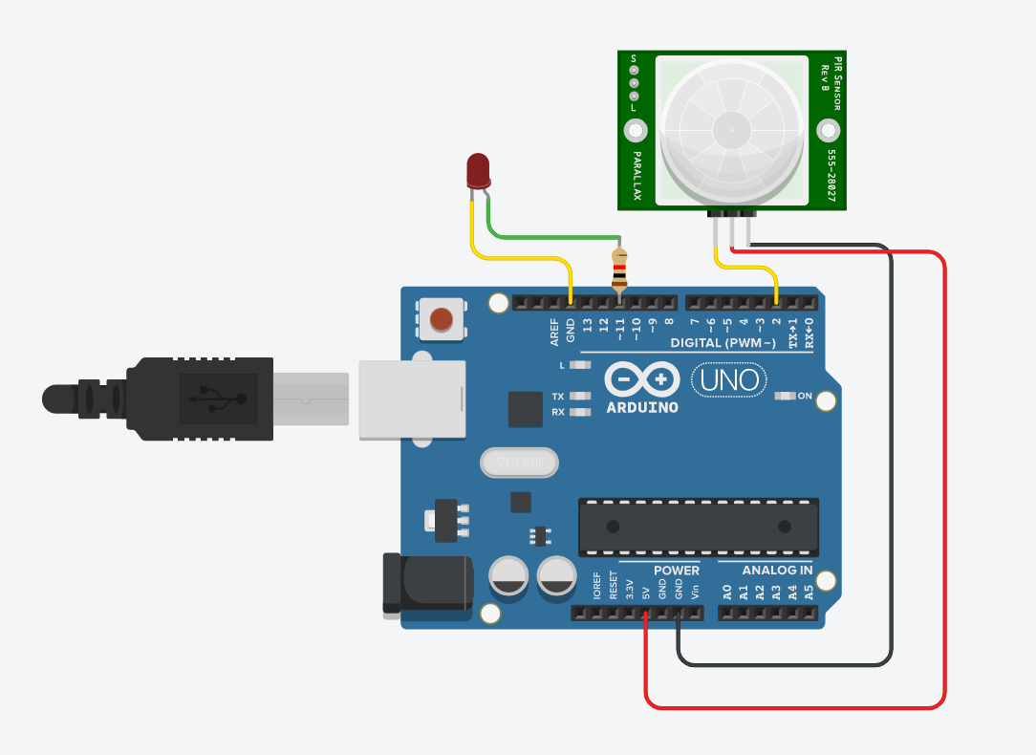**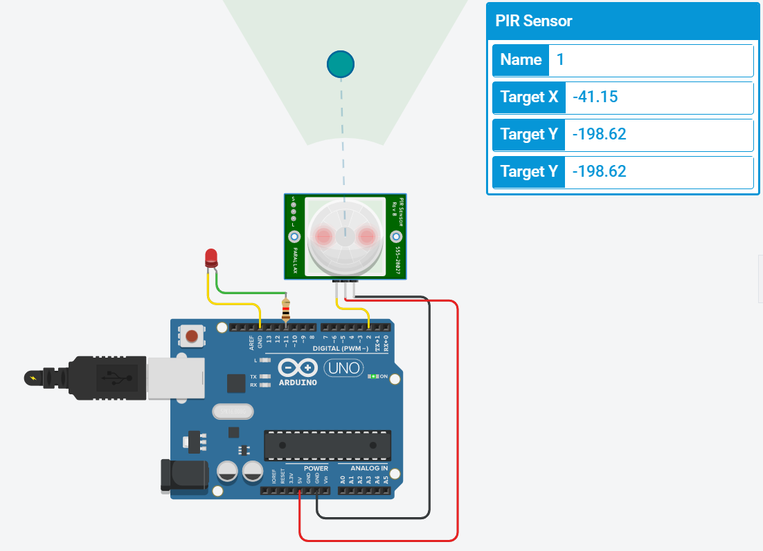Connection diagram on Tinkercad:**

**Video of implementation:**

( video shared in drive folder - <https://drive.google.com/drive/folders/1Weo53Dhk3O7L1L3kURVPr2Z-ZvkWV797?usp=sharing> )